**Moose – Wooden Animal**

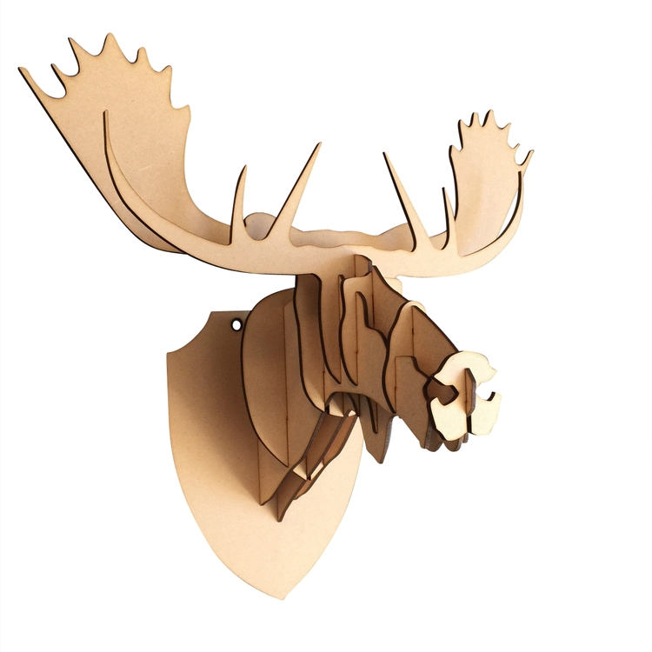A wooden moose sculpture or wall mount captures the majestic essence of this iconic animal, offering a unique and natural way to bring the beauty of wildlife into your home or cabin. Crafted from high-quality wood, these pieces often feature intricate details that highlight the moose's distinctive features, such as its broad antlers and strong, muscular frame. Whether it's a life-sized wall mount, a tabletop decoration, or a smaller carved figure, a wooden moose evokes a rustic, outdoorsy feel, making it a perfect addition to lodge-style interiors, living rooms, or entryways. The natural textures of the wood, combined with the moose’s powerful and graceful presence, add both warmth and character to any space, bringing the spirit of the wild into your home in a timeless, sustainable way.

1